4.1 Design a network to meet specified requirements.
Requirements
1.Build two LANs. Use at least one PC, one switch, one router for each LAN.
2.Configure the PCs and routers by assigning them hostnames, IP addresses, gateway. (No need to configure switch)
3.Configure static routes on the routers.

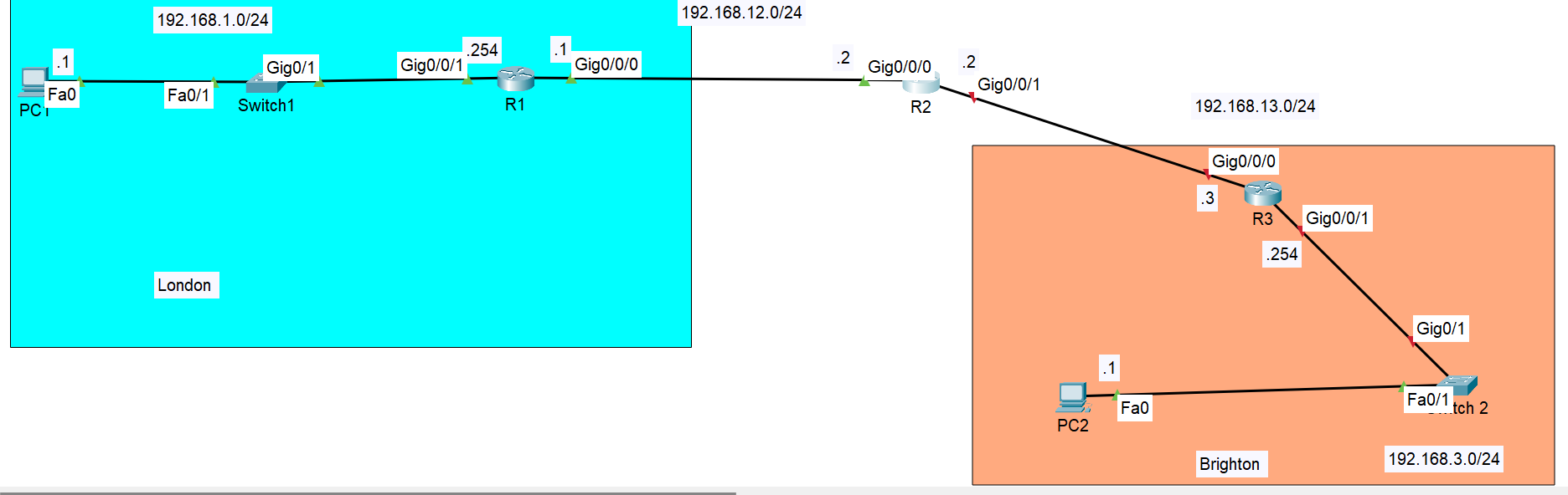
An example LAN design for office in London and Brighton. This network design is aim to configure static routes on the routers to enable PC 1 to successfully ping PC 2.
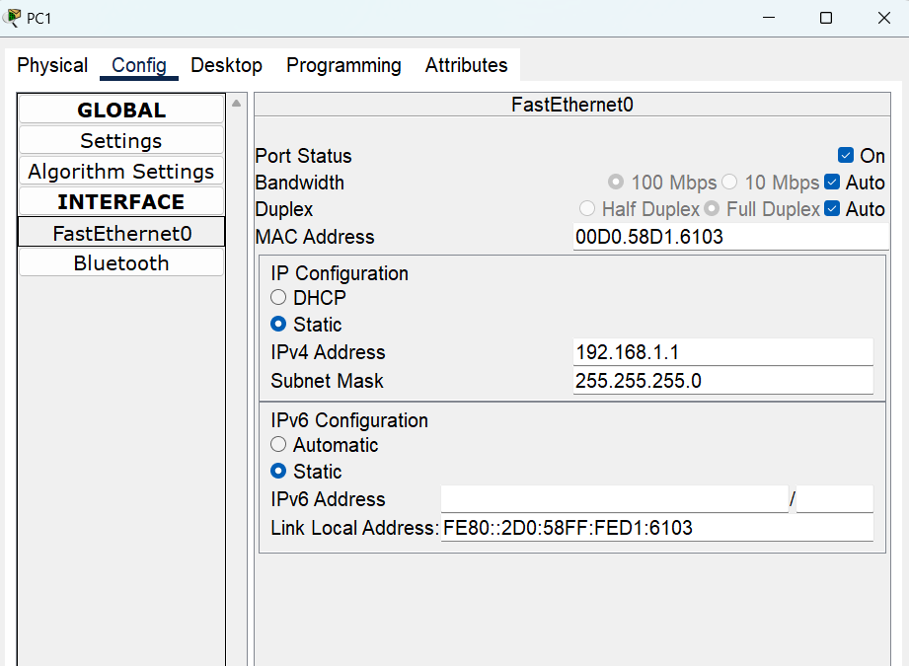
Assigning IP address and subnet mask for PC1.

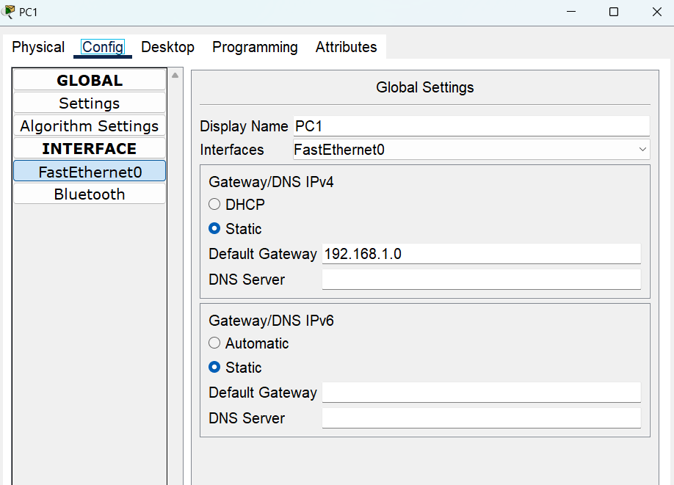
Configuring default gateway in PC1.
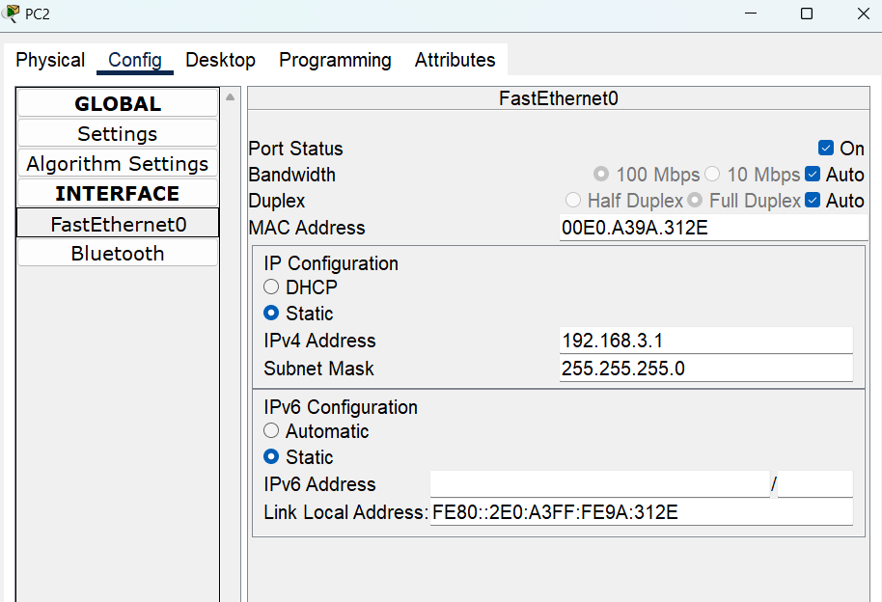
Assigning IP address and subnet mask for PC2.
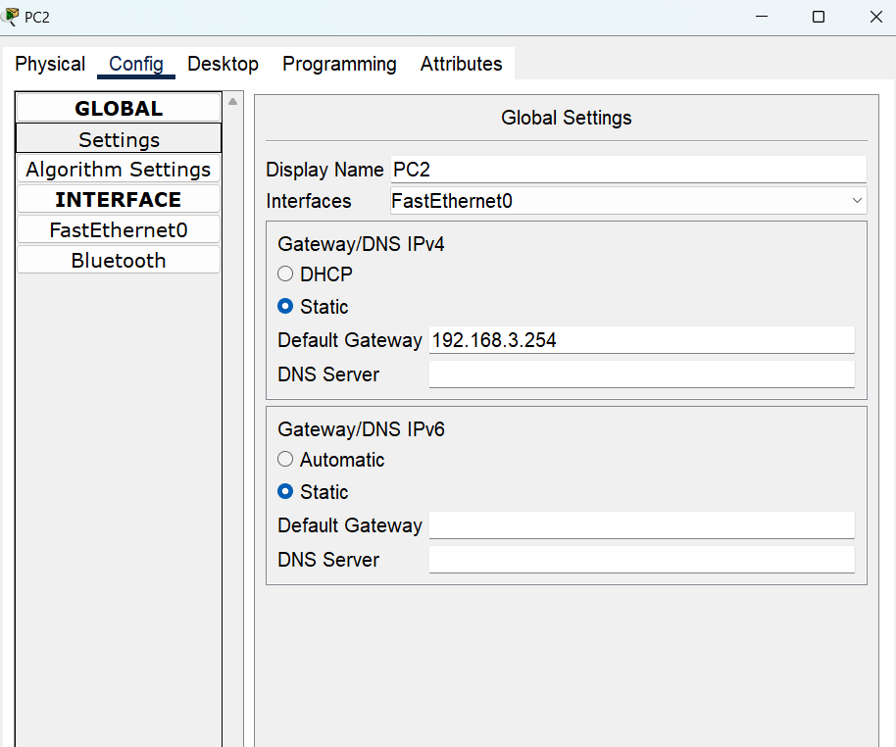
Configuring gateway in PC2.
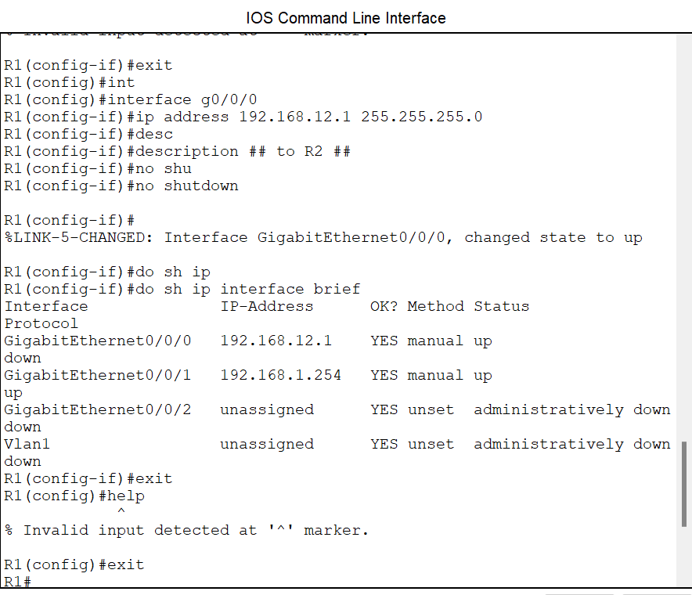
Router 1 configuration
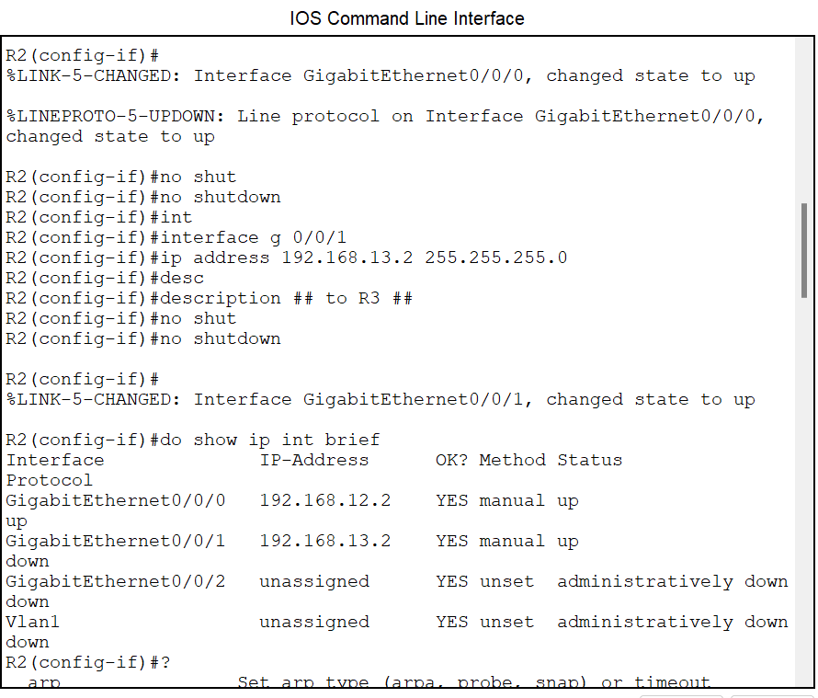
Router 2 configuration
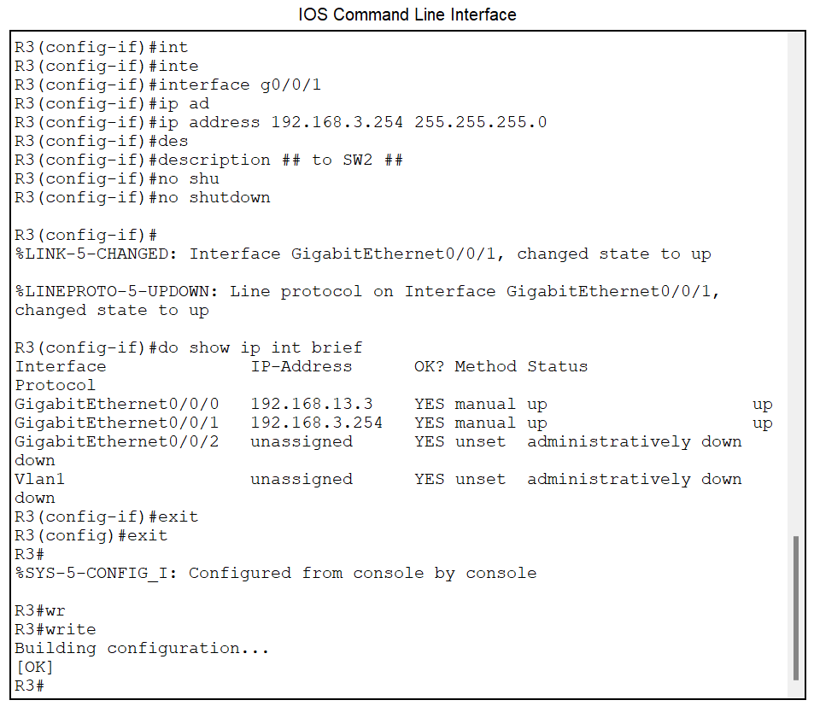
Router 3 configuration

Breakdown explanation for static route configuration
After we are done with the basic configuration, all we need to do next is to configure static routes. For this, we need two-way reachability:
- To reach PC1’s ping to PC2
- Then PC2 reply can reach to PC1
So, R1 is already connected to 192.168.1.0/24 network but it needs a route to 192.168.3.0/24 network.
Likewise, R3 is already connected to 192.168.3.0/24 network and it needs a route to 192.168.1.0/24 network.
But R2 is not connected to either of these networks, so it will need routes to both.
So that means a total of four routes need to be configured. One each on R1 and R3, and two on R2.
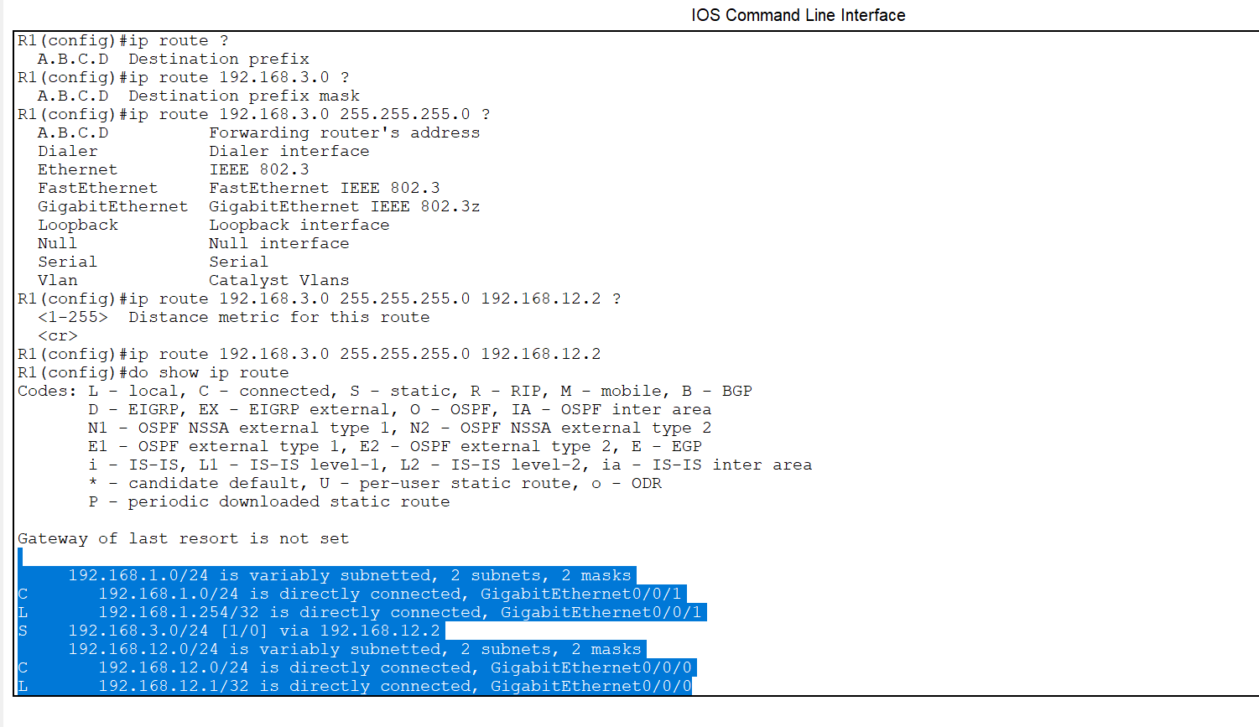
Step by step configuration of a route on R1

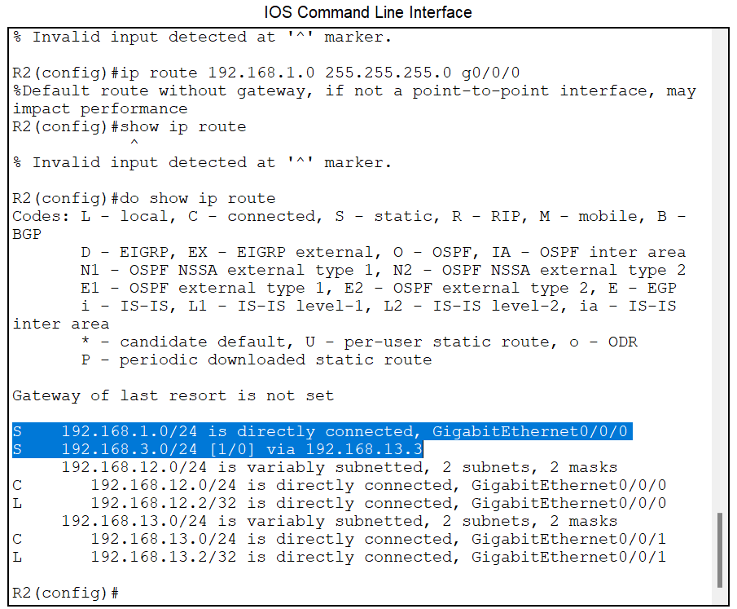
Two configured static routes in R2
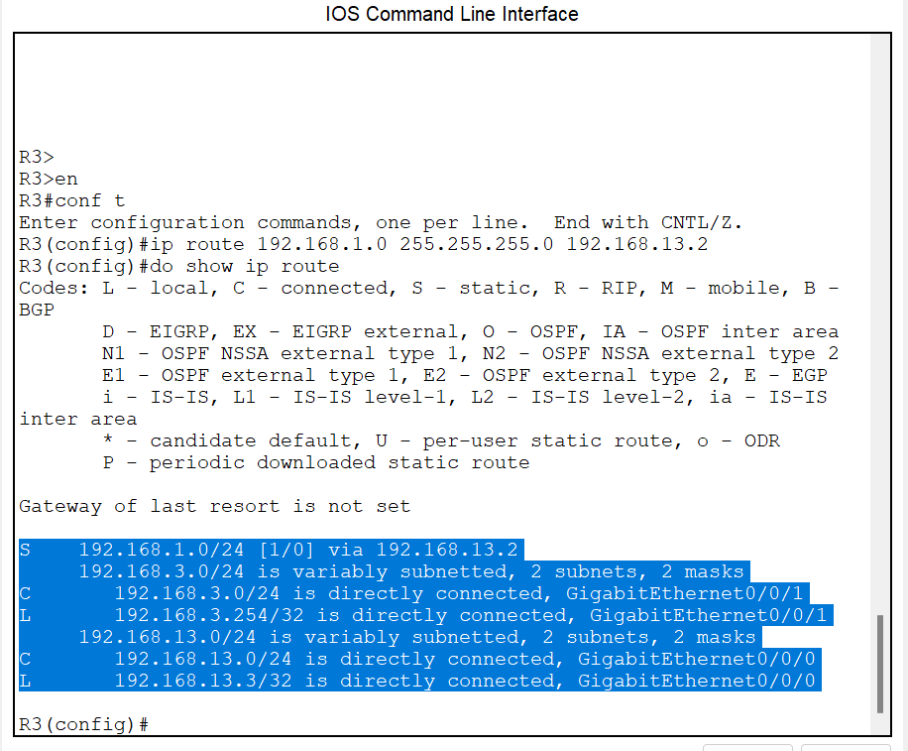
Static route configuration in R3. This figure shows one static route and the connected and local routes for each interface.

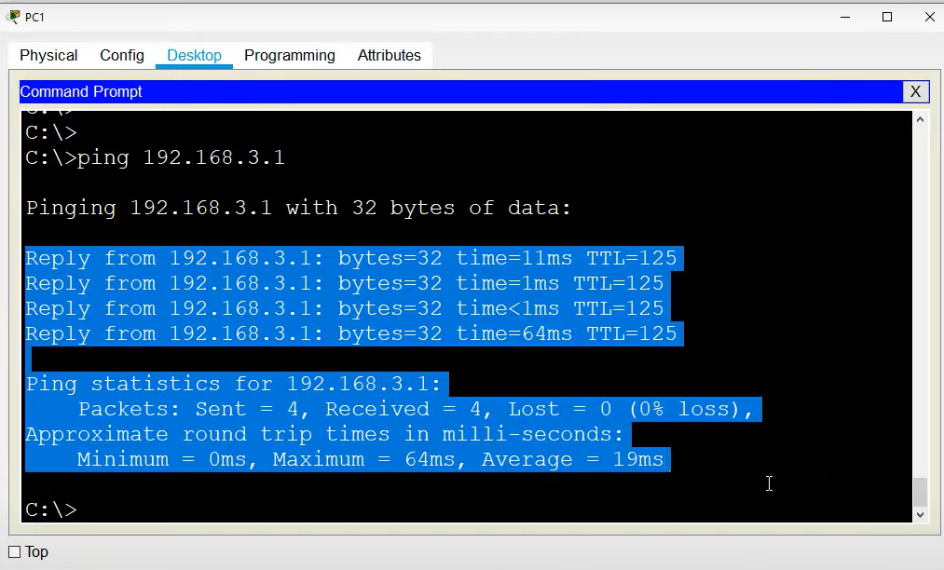
Here you can see PC 1 can successfully ping to PC 2 which means PC 2 is able to ping PC1 as well.
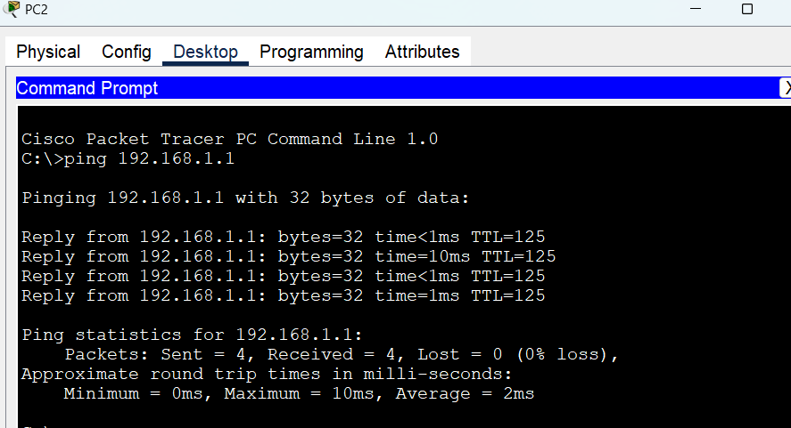
PC 2 ping is reachable to PC 1 in this figure.

